**Computer networks laboratory week 5**

**Name: Pranav R. Hegde SRN: PES1UG19CS343 Section: D**

**TASK 1: Socket programming(client server app)**

Simple client/server application using TCP

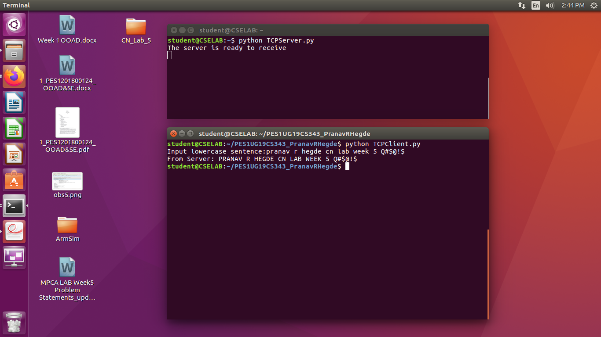

Simple client/server application using UDP

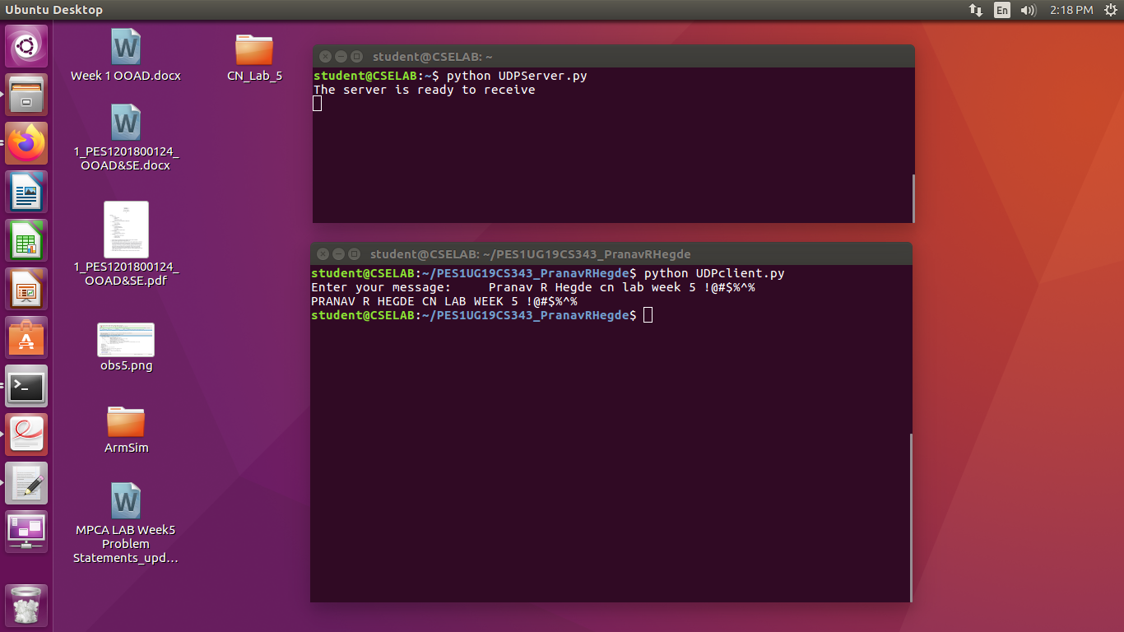

1.Suppose you run TCP Client before you run TCP Server. What happens? Why?

-> If the TCP client is run before the TCP server, the TCP client program throws an error. This is because a server is needed in order to establish a communication between the server and the client. If the client requests for a connection even before the server is active, the client program ends up throwing an error.

2.Suppose you run UDP Client before you run UDP Server. What happens? Why?

-> If the UDP client is run before the UDP server, the UDP client program throws an error. This is because a server is needed in order to establish a communication between the server and the client. If the client requests for a connection even before the server is active, the client program ends up throwing an error.

3.What happens if you use different port numbers for the client and server sides?

-> If a different port number is used on both the client and the server ends, communication is unsuccessful as port number is associated with each and every process. If two different port numbers are used, the communication is unsuccessful as they’re considered to be a part of two different processes.

**TASK2: Creating and running a Web server**

Wireshark capture on the server PC. Server ready to serve.

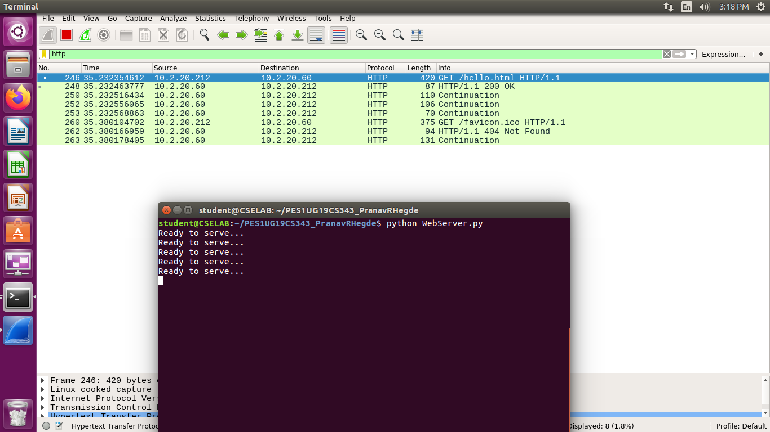

Wireshark packet capture of the first packet sent to the client.

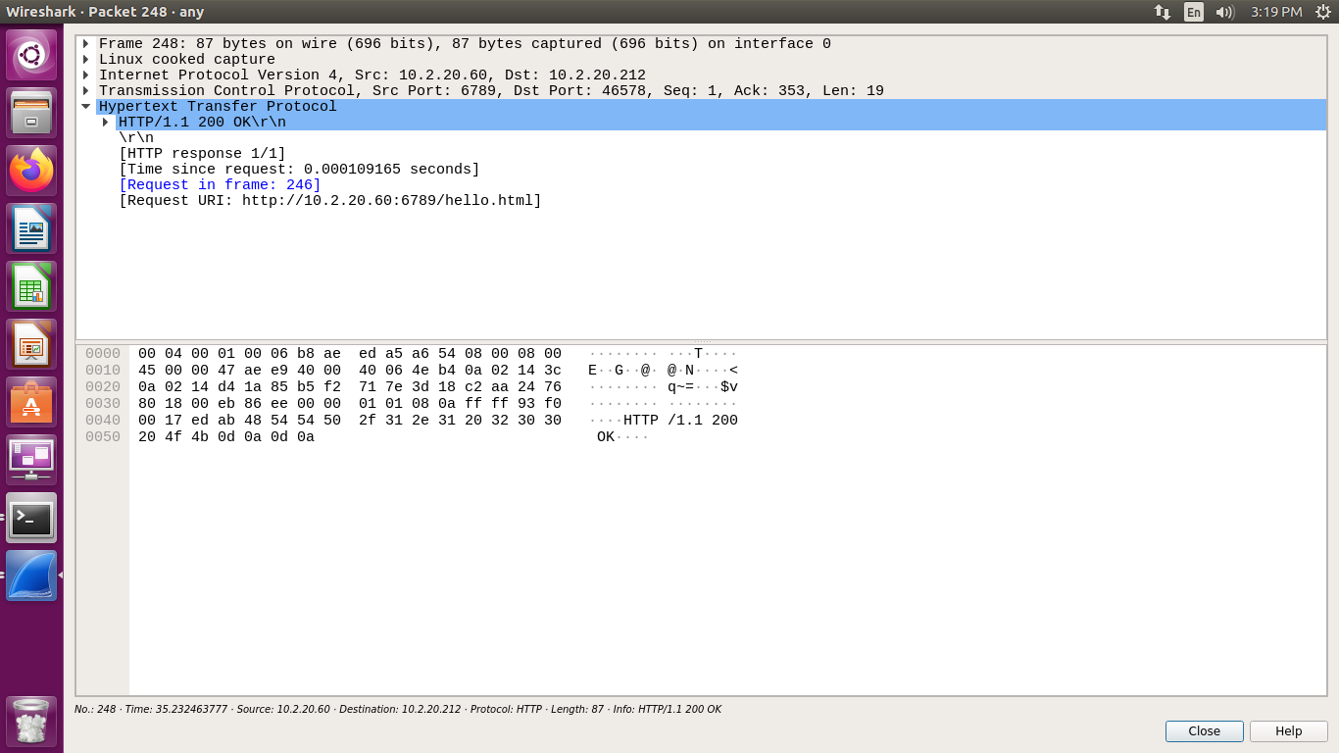

The webpage(hosted by the server machine) being accessed from the client machine.

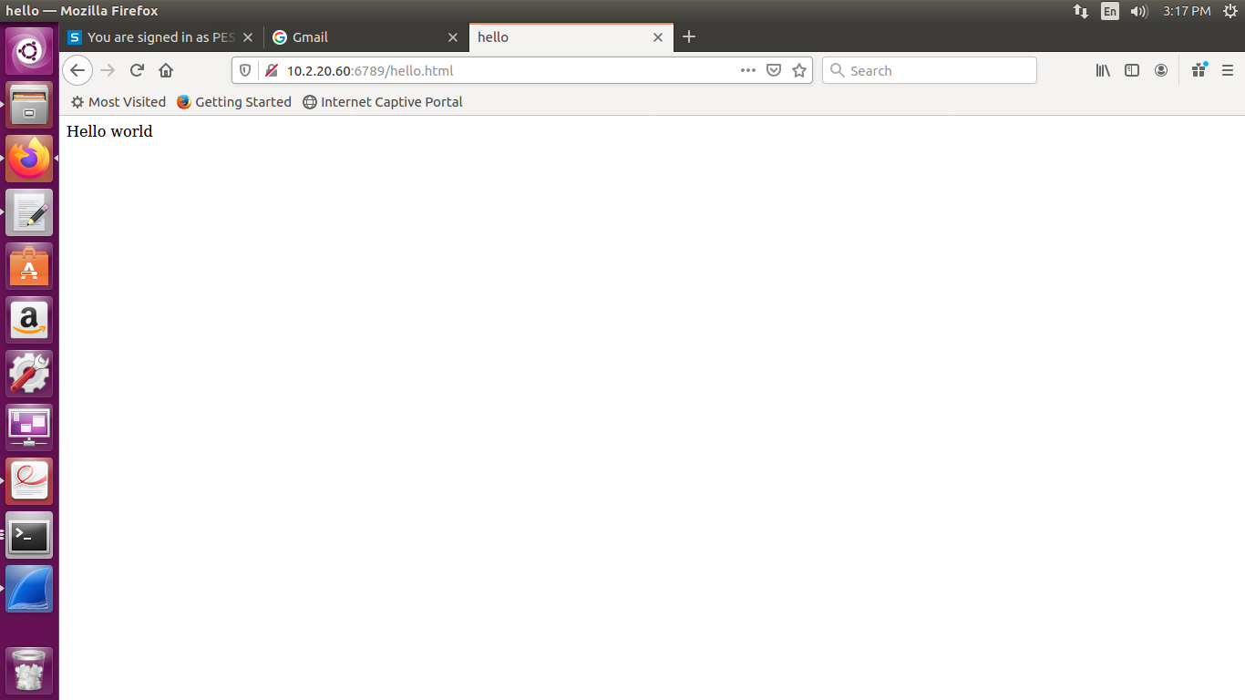

Accessing the webpage not present on the server machine. The client machine browser throws a 404 not found error.

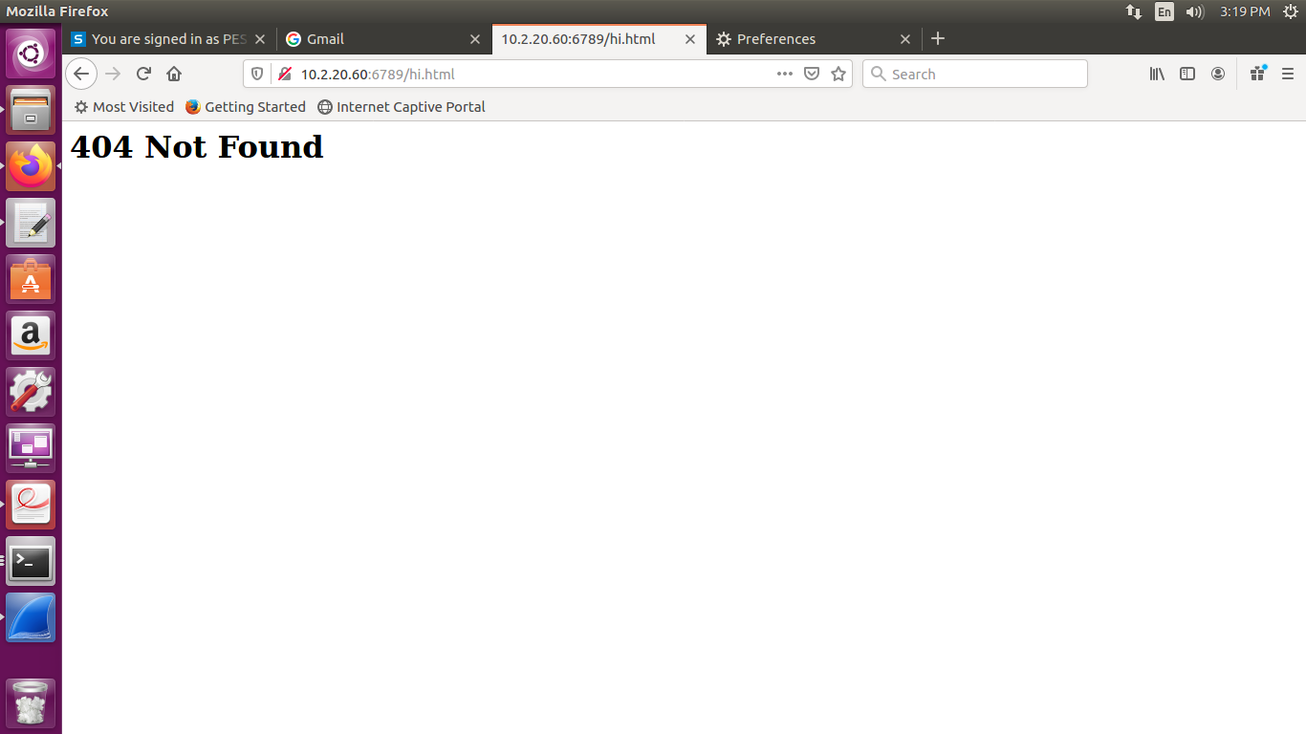

Wireshark packet capture data for the webpage not found on the server machine.

